Lecture 2
Recap:
What is the difference between Micro-Architecture and Macro-Architecture?:
macro-architecture is the higher level of the software structure, including what stack is used, what components exist and their relationship toward each other, the threading model, the Architecure model.
micro-architecture deals with each component specifications, what data structures are going to be used, what algorithm is to be used and so on.
What are the major skills a Software Architect should have?
Technical skills: micro-architecture and macro-architecture.
Analytical Skills: trade off analysis.
Soft Skills: communication skills, stakerholder management, and mentoring.

Recap: Quality and ISO 25010:
What is Software Quality?: it’s the degree to which a software satisfies its implicit and explicit requirements, whether its functional or non-functional. implicit means are taken for granted and not mentioned in the requirements.
example ChatApp:
Ps: requirements that are implicit are non-functional while the explicit are functional requirements.
Which requirements would you mention explicitly?:
User registration and login, One-to-one messaging, Group chat (max 50 users), File sharing (images up to 10MB), Read receipts (seen/ delivered), Typing indicators.

Which requirements would you take for granted?:
• Security, Availability, Performance, Reliability, Usability, Scalability.
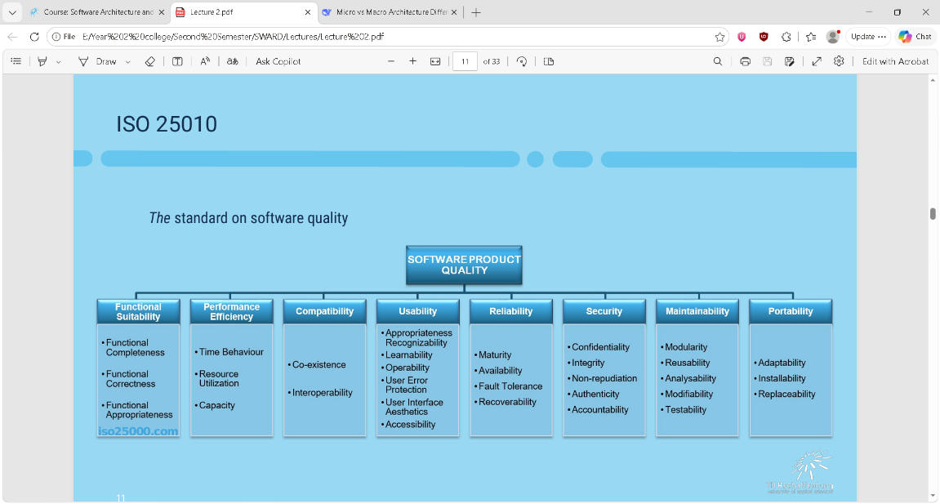
- Completeness: All specified functions exist.
- Correctness: Functions produce accurate results.
- Appropriateness: Functions are relevant to user goals (no useless features).

How can we check if a software architecture is good/bad for a specific quality attribute?:
To check an architecture for a quality attribute, write a measurable scenario (stimulus + measure), then verify the architecture has the tactics to achieve that measure. Your login-blocking test is correct in spirit, but must specify under what conditions, how fast, and for how long to be a true quality attribute test rather than a functional test.

How do we specify measurable quality goals for our architecture? aka How do we check if a software architecture is good?:
A software architecture is "good" if it demonstrably satisfies its measurable quality goals while balancing trade-offs.
example: in case of a brute force, we write a scenario of an attacker that tries to brute force another user's password this is the scenario, the measurements are that this action is blocked, logged into our system. and this checks for security quality in our architecture

Architecture Evaluation Techniques:
referring to the graph, the down we go the later it comes, and the more details it jumps into:
Questioning, scenario based, measuring, quantative, emulation, compliance checking.
Quality Scenarios:
Scenario: a short statement describing an interaction of one of stakeholder with the system.
Scenarios and prioritization are defined by the stakeholders; those stakeholders include the developers of the software.
Examples:
a user using the system to do a task
a maintainer upgrading the OS,
Developer: Uses the architecture, to build systems; predicts Quality of Service
Product-line-manager: Uses a reference architecture to create a second product for a given product line
TLDR: quality attribute scenarios are a one statement of a use case done by one of the stakeholders, these are prioritized by the stakeholders and later are used to design a measurable quality attribute check using scenario based quality check.

Scenario-based Architecture Evaluation:
Architecture can be evaluated by analyzing the effects of a scenario and the architecture’s „response“.
every time we do a scenario-based architecture evaluation we should ask these 6 questions
- How to implement the scenario with the given architecture?
- Can all (quality-)requirements be met? If no: why?
- What changes have to be made in order to meet the scenario’s requirements?
- Which design decisions have to be made?
- How much work is it? How many components have to be changed?
- What risks result from meeting the scenario’s requirements?

Example:
Scenario: "Under 1000 concurrent users sending 1 message per second, the system must deliver each message within 200ms."
# | Question | Example 1
1 | How to implement the scenario with the given architecture? | "Messages go through a load balancer to multiple message service instances, then to a database."
2 | Can all quality requirements be met? If no: why? | "No — database writes take 150ms alone, plus network and processing pushes total to 350ms."
3 | What changes have to be made to meet the scenario's requirements? | "Add a Redis cache for active message threads and batch database writes."
4 | Which design decisions have to be made? | "Cache TTL: 5 seconds or 30 seconds? Batch size: 10 messages or 100?"
5 | How much work is it? How many components have to be changed? | "3 components: message service, Redis cache, database. Estimated 3 days."
6 | What risks result from meeting the scenario's requirements? | "Cache inconsistency — users may see stale messages if cache not invalidated properly."

Quality Attribute Scenario Notation:
Source: entity that generates the stimuli. for example in this case the user. (user)
Stimulus: condition that requires a response from the system when it arrives. (initiates a transaction)
Artifact: the part of the system that is affected, which our requirements apply to (our system)
Environment: the conditions in which the stimulus happen (normal conditions in production)
Response: what the system must do (transcation is processed)
Response measure: measurable pass/fail criteria. (latency of 2 seconds)

What is a scenario same as before in a different way:
the artifact represents the product, and can be called the system it can also refer to a subsystem, a server or even a microservice.
the source refers to the trigger it can be a user, a persona.
The Stimulus describes the action on the product. This can be a use-case or function call.
The Response describes the artifact’s answer or reaction to the stimulus.
The Response Measure formulates an evaluation on how well the scenario has been completed – e.g., a target time or another metric.
The Environment is used to describe the context in which the artifact produces the response with it’s response measure. Use this construct to describe boundaries within which certain product behavior should be expected.

Quality Attribute Scenarios: Examples
Example 1: scenario for measuring the performance quality attribute
Source: user
stimulus: makes a transaction
artifact: our entire system
environment: normal production environment
response: transaction is processed by the system
response measure: latency of 2ms

Example 2: scenario for measuring the modifiability attribute
Source: the developer
stimulus: wants to change the UI
artifact: our code
environment: still in design/dev
response: modification is made with no issues
response measure: 3 hours

Example 2: scenario for measuring the resilience attribute (important!!!)
Source: Server
Stimulus: The power is cut off
artifact: our game server
environment: before noon few players active
Response: the game switches to another server
Response Measure: 2 minutes

How do we get quality scenarios from our stakeholders?:
To get quality scenarios from stakeholders, you interview them using open-ended questions about their concerns (e.g., "What failures worry you?" "How fast must recovery be?"). You then translate their answers into the formal six-component notation (source, stimulus, artifact, environment, response, response measure). Finally, you validate the structured scenario back with the stakeholder to ensure accuracy before prioritization and evaluation. Stakeholders provide concerns and boundaries — architects provide structure and measurability.

Architectural Trade-Off Analysis Method (ATAM):
Human-centric process for identifying risks early on in software design; meaning this method is done by humans with no automation, its done early in the development process where most of the code is not written we analyze what trade-offs we get after we prioritized the non-functional requirements.

we analyze the trade offs that we have in the mentioned 4 qualities by our given architecture:
- Modifiability
- Security
- Performance
- Reliability

Purpose:
it reveals how well an architecture satisfies each quality goal (e.g., 'Security goal is met') and identifies trade-offs between goals (e.g., 'Security hurts Performance'). for example, for the modifiability we may give access to some developers. but to satisfy this quality we will trade off some security
it compares different architectural decision alternatives (e.g., single database vs. distributed database) and assesses their consequences against the stakeholders' quality requirements — enabling informed decisions based on priorities. it means that we check our architecure and check the alternative design. to see how it would affect our quality attributes.

Pros & Cons:
easy to apply for all type of stakeholder, no formal method needed, structured and guided approach, explicit goals and scenarios.
requires experience and good, depends on the skills of the stakeholders
ATAM – Conceptual Flow:
The ATAM conceptual flow starts with business drivers, quality attributes, and scenarios as inputs. It analyzes the software architecture, architectural approaches, and decisions to find dependencies, impacts, and trade-offs between quality attributes. It then identifies sensitivity points (where small changes have big effects), risks (potential future problems), and non-risks (good decisions). These are distilled into risk themes, and the process repeats until all major risks are properly mitigated. The risk has been reduced to an acceptable level

What comes before analysis? | Business Drivers (Why are we building this?), Quality Attributes (What non-functional goals matter?), Scenarios
What do you analyze? | Software Architecture, Architectural Approaches, Decisions
What comes after analysis? | Risks, Non-risks, Sensitivity Points, Risk Themes
What do you do next? | Repeat until risks are mitigated

ATAM business Drivers:
The system critical functionalities; the most important features
Any technical, managerial, economic, or political constraints
The project’s business goals
The major stakeholders: the user, admin, regulatories
the most important NFPs nun-functional properties

ATAM – Architecture:
We analyze the technical requirements and how they affect our quality attributes.
Technical constraints; Required hardware platforms, OS, middleware, programming languages, and OTS functionality
any other system that system interact with or rely on
Architectural approaches that have been used to meet the quality requirements, Sets of architectural design decisions employed to solve a problem Typically architectural patterns and styles
ATAM – Analysis The key step:
Objective: Analysis step is to understand, for each architectural approach (e.g., caching, encryption, microservices), whether it has a positive, negative, or neutral relationship with each quality attribute (Modifiability, Security, Performance, Reliability). This reveals which decisions help your goals and which decisions hurt them.
Based on answers, further analysis may be performed
In ATAM analysis, architects and the evaluation team identify four things: Risks (potential future problems, grouped into risk themes), Non-Risks (safe, good decisions), Sensitivity Points (where small changes have big effects on quality), and Trade-off Points (where improving one quality hurts another). These outputs guide mitigation efforts and inform architectural decisions.

ATM Outputs:
a clear summarized description of the software architecture
The stakeholders' priorities are documented as formal, measurable scenarios (source, stimulus, artifact, environment, response, measure)
A traceability matrix showing which architectural decisions affect which quality attributes (positively or negatively).
A documented list of potential problems (risks) and safe decisions (non-risks), grouped into categories (risk themes) based on our architectural decisions.
why do we have this system from a business wise point of view and what successful means for the business using this system

